# Feature scaling part 1

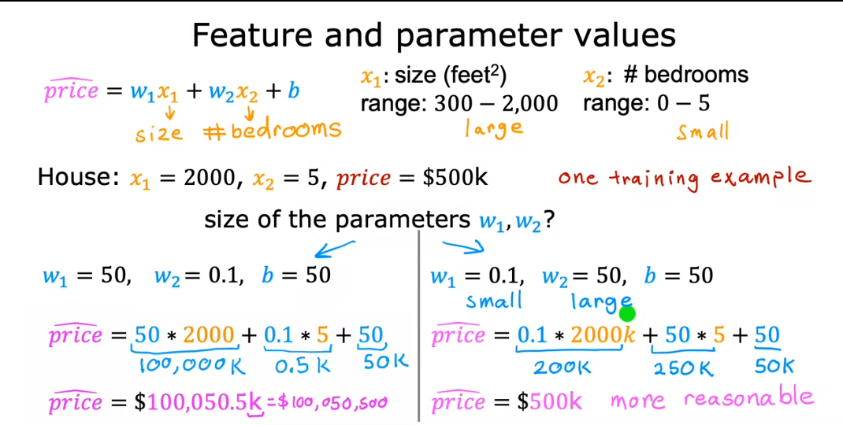

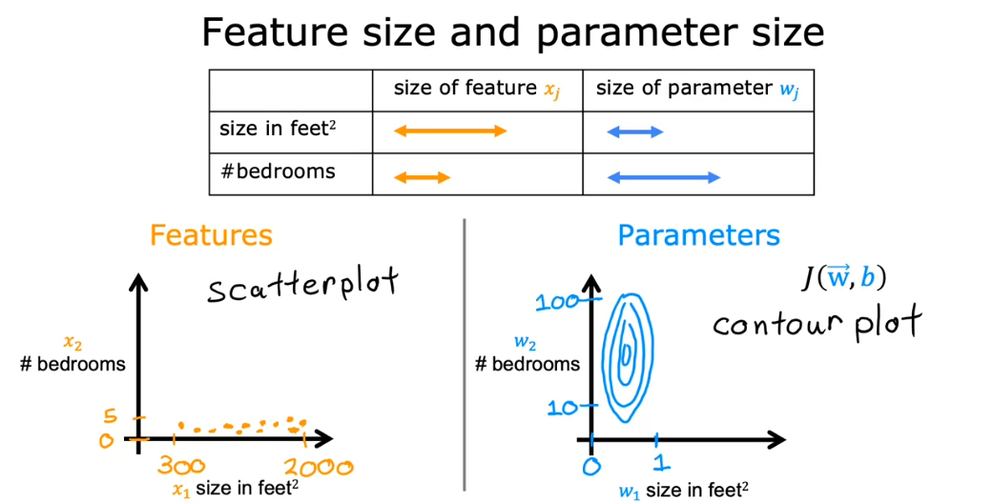

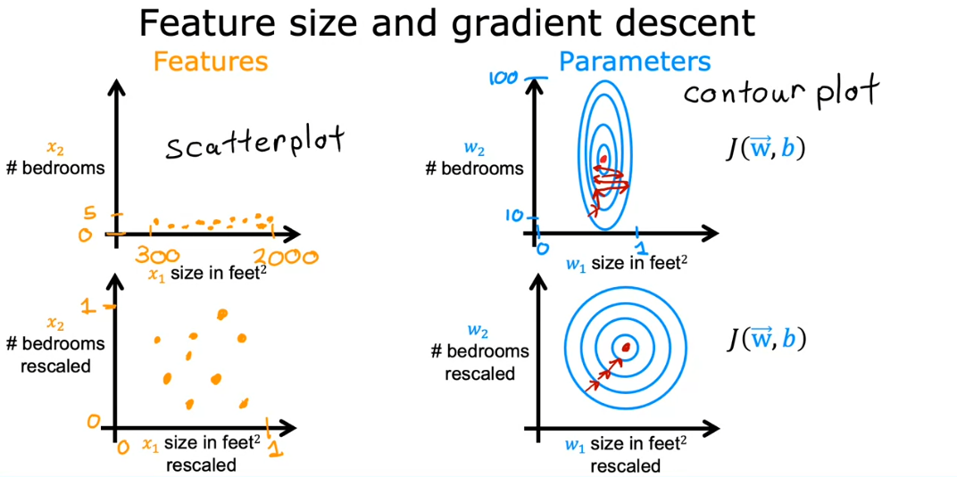

# Feature scaling part 2

## Dividing by the Maximum

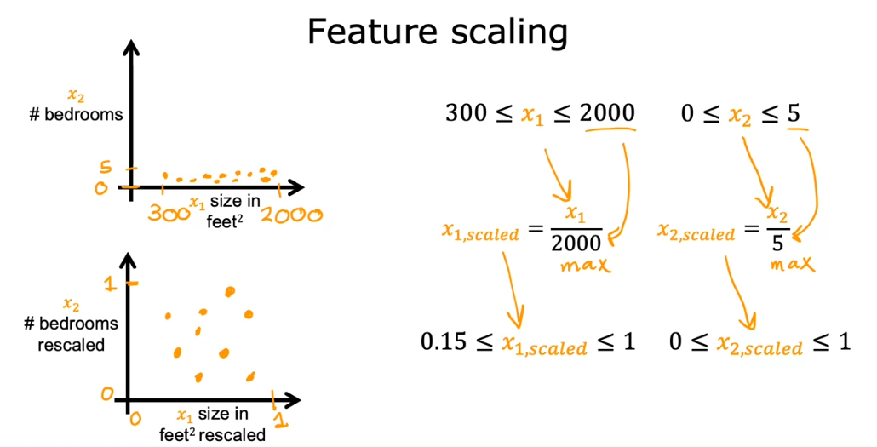

## Mean normalization

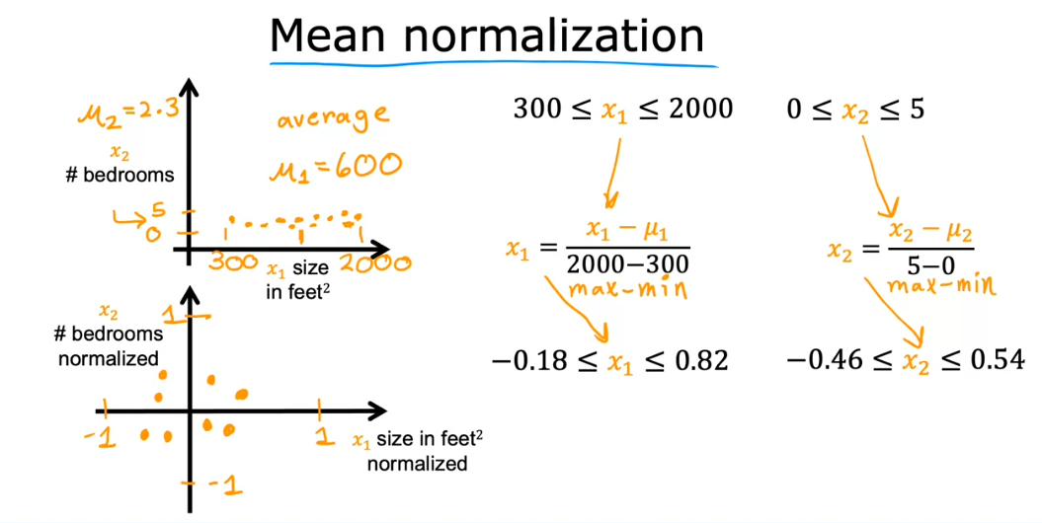

## Z-score normalization

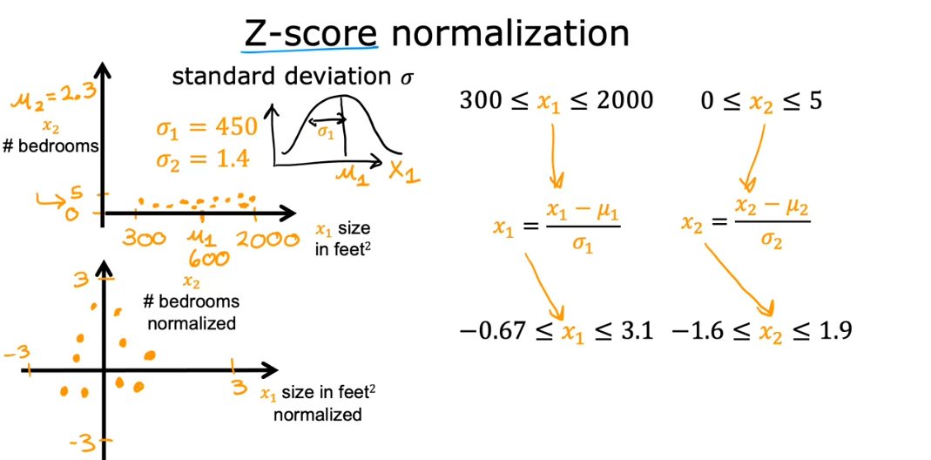

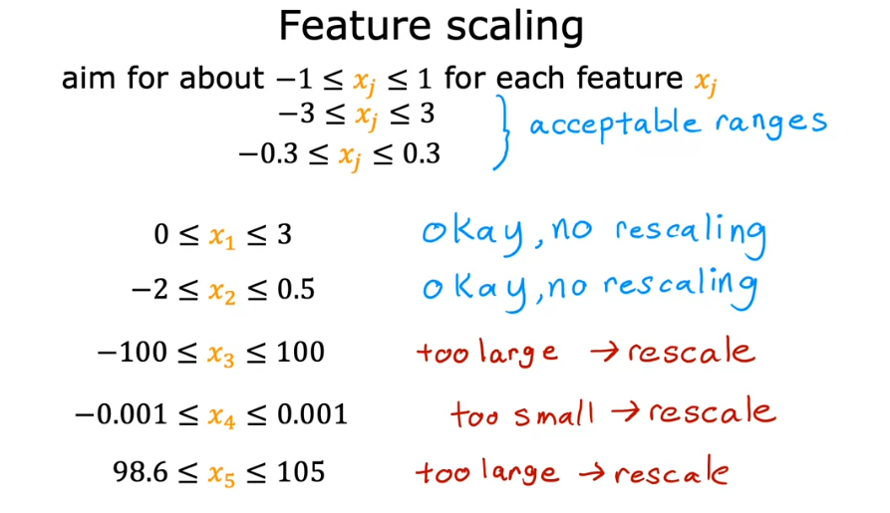

* When in doubt, just rescale! No harm in any way

# Checking gradient descent for convergence

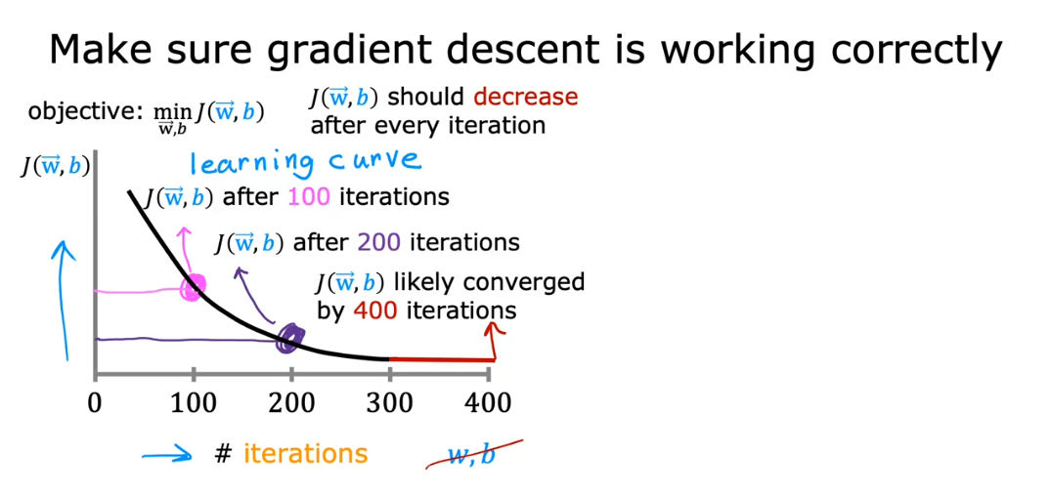

* Even only in one increase of cost J:
  + A bug in the code
  + Poorly chosen alpha
  + Gradient descent not working correctly already
* Must always decrease no matter what!

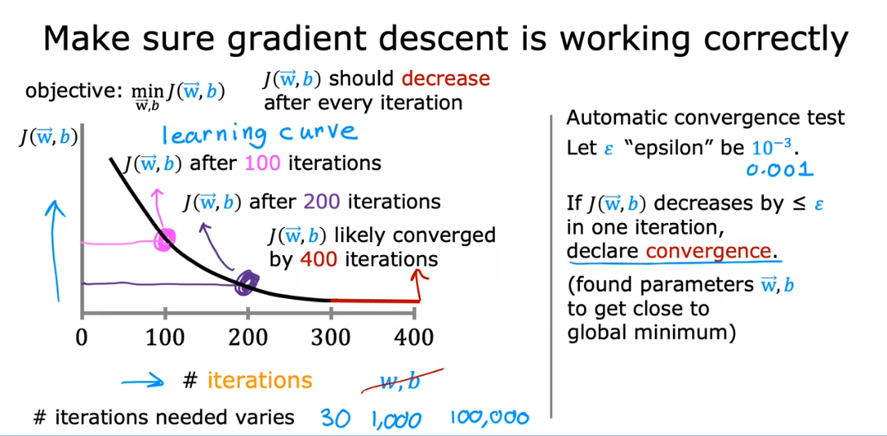

* The graph is more reliable than the automatic convergence tests

# Choosing the Learning Rate

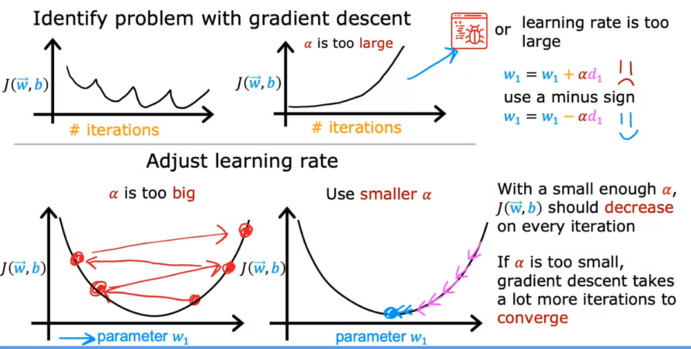

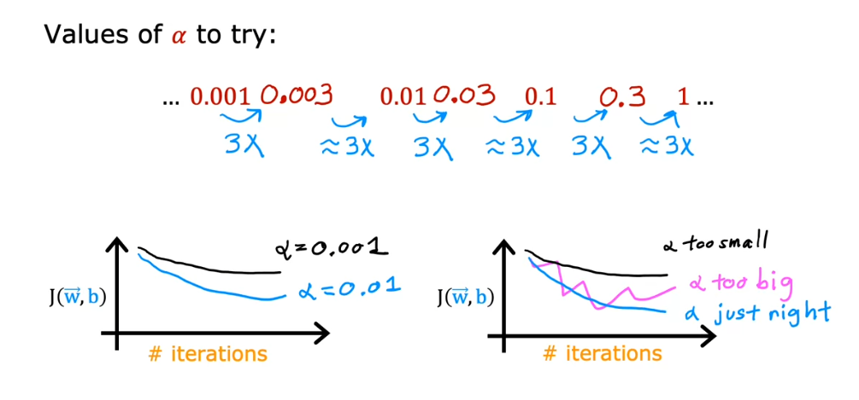

* Technique:
  + Find too small,
  + Then find too big
  + Then go from that range

# Feature Engineering

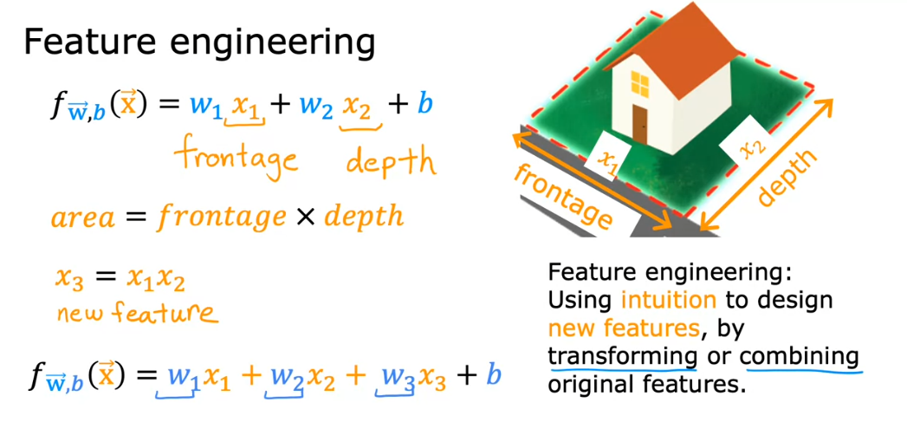

# Polynomial Regression

